- Convert the ERD shown in Figure 4 into tables. List the conversion rules used and the resulting tables with primary keys, foreign keys, other columns, and not null constraints for foreign keys. You do not need to provide CREATE TABLE statements.
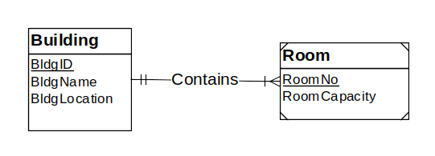
Figure 4: ERD for Problem 4

Solutions :

Result after conversion
Building(BldgId, BldgName, BldgLocation)

Room(BldgId, RoomNo, RoomCapacity)
FOREIGN KEY(BldgId) REFERENCES Building

Conversion rules
- Use the entity type rule to convert the Building and Room entity types.
- Use the 1-M relationship rule to convert the Contains relationship into the BldgId FK in the Room table.
- Use the identification dependency rule to make BldgId a component of the PK of Room. The PK of the Room table is a combination of BldgId and RoomNo.
- In the final conversion result, a not null constraint is not needed for Room.BldgId because this column is part of the primary key of Room.

